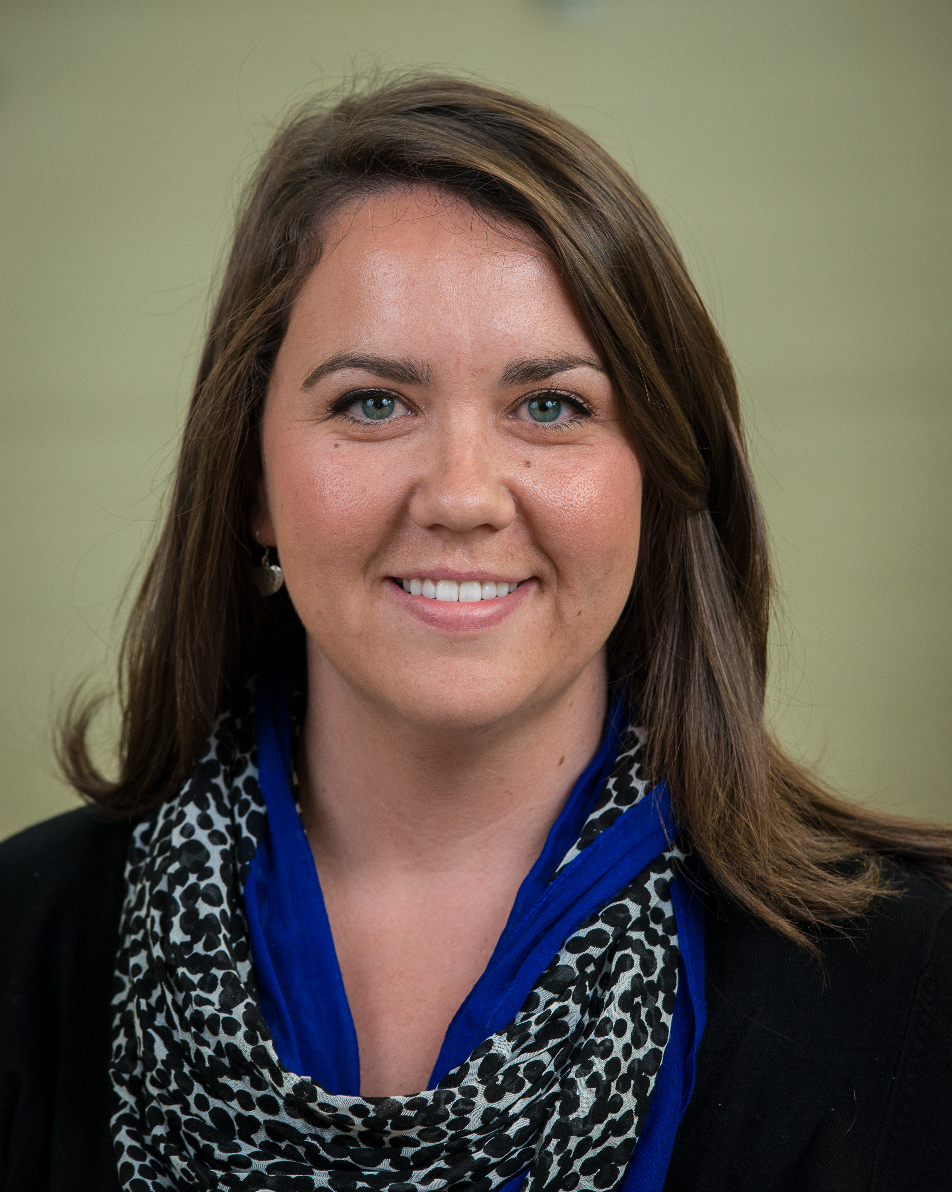
Oceans Technology Advanced Diploma

Jennifer Feehan, B.Sc., M.M.S.

As a member of the first graduating class of the Oceans Technology Advanced Diploma at NSCC, I am excited to gain the hands-on technical skills that will build upon my prior knowledge, and improve my understanding of the ocean and its technologies.

My academic background reflects my keen interest in biology, fisheries, and coastal and ocean management. I obtained a Bachelor of Science in Biology and Aquatic Resources at Saint Francis Xavier University. These studies were followed with the Master of Marine Studies program at Memorial University of Newfoundland. I completed this multi-disciplinary graduate program with high academic standing, which is testament to my strong research skills, ability to meet deadlines under pressure, and extensive understanding of the ecological, political, economic and social aspects involved in fisheries management.

I have five years of work experience at the Northumberland Fisheries Museum’s Lobster Stock Enhancement Research Project in Pictou, Nova Scotia. I played a key role in the development and implementation of the Lobster Hatchery, and my performance resulted in my promotion from Summer Intern, to Hatchery Technician and later to Hatchery Manager. Essential to the management of the hatchery were my excellent organizational and project management skills, along with my ability to excel under minimum supervision and as part of a team. My strong written and oral communication skills were crucial when collaborating with members of the scientific community, government officials and the local fishermen’s association.

Education
- Saint Francis Xavier University
  - Bachelor of Science in Biology and Aquatic Resources
- Memorial University of Newfoundland
  - Master of Marine Studies (Fisheries Resource Management)

Certification
- Standard First Aid Training Level C CPR / AED
- Occupational Health and Safety
- Workplace Hazardous Materials Information System
- Marine Emergency Duties A3

Professional Achievements
- Senior Seminar Paper and Presentation: Decline of the Lobster Population in the Northumberland Strait and the Development of a Proactive Method to Deter this Decline: The Lobster Stock Enhancement Research Project
- Presenter at the Atlantic Veterinary College’s 4th Annual Lobster Science Workshop Growing the Resource: Lobster Enhancement and Health Strategies
- Interviewed for CBC Production Land and Sea
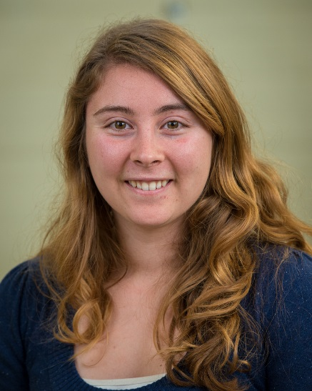
Nova Scotia Community College
Oceans Technology Advanced Diploma
Amy Lawrence
Professional Synopsis:
I am a hardworking and motivated student with a strong biology background. Through group and individual projects in university, I have proven my ability to work effectively with others and individually. I am eager to learn and put my full effort into everything I undertake. I look forward to furthering my education in the Oceans Technology Advanced Diploma program so that I can develop the skills necessary to work in the oceans technology industry. Through courses such as Marine Mechanical Systems, Marine Instrumentation, and Marine Acoustics, I will become proficient in deployment and maintenance of instruments, as well as limitations and trouble-shooting.
Education:
- Saint Mary’s University
  - Bachelor of Science with a major in Biology
Background:
- Continuing education to gain a rewarding career, in which I can apply past education and experience in combination with skills gained from the Oceans Technology program.
Previous work experience / project experience:
- Math Marker for Saint Mary’s University
  - Corrected and provided feedback on approximately 100 quizzes per week for Pre-Calculus, and Calculus.
- Field Research Technician for CB Wetlands & Environmental Specialists .
  - Collected data on plants, fish, and soil salinity and entered data using Microsoft Access as part of monitoring plans for restored wetlands.
- Biology field course in China
  - Completed a project on tadpoles in a rural community in China.
  - Spent one week in Viet Nam, a month in China, and a week in Japan learning about different cultures, and gaining knowledge of exotic flora and fauna.
Other information:
- In my free time, I enjoy running with my two dogs, Scarlett and Maxi. In the summer, I like hiking and camping.
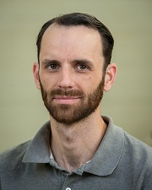
Adam J. Nelson
Background:
I was born and raised in Yarmouth, Nova Scotia. Upon graduating high school I completed the Katimavik youth volunteer program which took me all over the country working at various volunteer positions in each community. After Katimavik I worked different sales and kitchen jobs all the while playing music in one or more projects. In 2012 I decided to return to school and re-train as an electronics technician. I graduated with honors from the Electronic Engineering Technician program at NSCC Pictou campus last spring and subsequently enrolled in the Ocean Technologies advanced diploma program at NSCC Waterfront campus.
Education:
Nova Scotia Community College Sept ’14 – Present
Advanced Diploma in Ocean Technologies
Nova Scotia Community College Sept ‘12 – May ‘14
Diploma in Electronic Engineering Technician
St. Francis Xavier University. Sept ‘04 – Dec ‘05
Diploma in Jazz studies
Yarmouth Consolidated Memorial High School Sept ‘97 – June ‘00
Academic Diploma

Recent Work Experience:

Polyblend Systems/Diamond Pedals Dartmouth, Nova Scotia
Technician May ’14 – Sept. ‘14

Settler's Salt Water Cafe Pictou, Nova Scotia
Line Cook June ‘13 – Sept. ‘13

Halifax Cycle Gallery Halifax, Nova Scotia
Sales / Service Summer ‘11

Sobeys Halifax, Nova Scotia
Deli/Produce Clerk March ‘11 – December ‘11

Hamachi Kita Sushi and Asian Flare Halifax, Nova Scotia
Kitchen Manager/Thai and Japanese Cook March ‘09 – October ‘10

Metasoft Systems Inc. Halifax, Nova Scotia
Account Manager May ‘08 – March ‘09

Minacs Worldwide / Aditya Birla Minacs Halifax, Nova Scotia

Designated Trainer Aug. ‘07 – May ‘08

Telecommunications Sales Representative Feb. ‘07 – May ‘08

Outlander Productions Halifax, Nova Scotia
Background Performer Oct. ‘06 – Jan. ‘07

TigerTel/UTR Dartmouth, Nova Scotia

Customer Service Representative Feb. ‘06 – Oct. ‘06

Rassy’s Pizza Halifax, Nova Scotia
Cook Jan. ‘06 – Feb. ‘06

Jakes Diner Yarmouth, Nova Scotia
Prep Cook and Dough Boy Apr. ‘04 - Aug. ‘05

Other Qualifications/Achievements:
Ideas Entrepreneurship Competition
Pictou Campus - 1st Place Feb 17, 2014
Provincial - Participant March 20, 2014
Nova Scotia Skills Competition
2nd Place - Electronics March 28, 2014
Canadian Kendo Federation Grading
Nidan Nov 27, 2010
WHMIS 2013
OHS 2013
First Aid (St. John Ambulance) 2013
Lockout / Tag-out 2014
Respiratory Protection 2014
MED A3 2014
Fall Protection 2014
Bilingual (English/French)

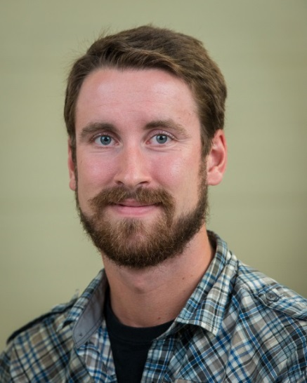
Callum Mireault
Professional Synopsis:
I am dedicated individual who takes pride in putting my work first and foremost in my life. I have a vast repertoire of theoretical knowledge through marine biology, oceanography, statistics and mathematical modelling courses at Dalhousie University. My skills extend beyond the classroom as demonstrated by my work in my honours thesis where I prepared my entire thesis from planning and design, to field data collection and the final steps of data manipulation and presentation. I have spent my entire life working in a healthy balance of team and independent environments and excel in both areas respectively. The Oceans Technology program presents a unique opportunity for me to branch into the tech side of marine biology and oceanography and gain the practical skill set that the oceans industry is looking for.
Objective:
- To find a job in the oceans technology sector as an ocean technologist where I can create and implement experimental designs for a wide variety of research initiatives.
Education:
- Honours BsC Marine Biology, graduated from Dalhousie University May 2014.
Background:
- 5 years spent at Dalhousie University obtaining my marine biology degree
- The field methods and field work aspect of marine biology was a better fit to my lifestyle than the report writing and research portions of the discipline which led me to pursue different avenues of work than my peers.
- Gained a taste of true field work at the Tim Horton’s Children’s Camp where I gathered data for my thesis and used skills to establish a marine centre for the camp.
Work Experience:
- Lifeguard – frontline, guard supervisor, co-coordinator of aquatics, waterfront coordinator
- Data extraction intern for Lafarge Concrete and Aggregates
- Bilingual program staff and marine biologist at the Tim Horton’s Children’s Camp in Tatamagouche, NS.
Project Experience:
- 407 Highway expansion project for Lafarge Concrete and Aggregates
- Environmental Impact Assessment completed for BIOL 4001: Environmental Impact Assessment course at Dalhousie University
- THCC marine centre, touch tank and educational outreach development and maintenance
- Honours Thesis: scientific method design, construction of a custom GoPro camera quadrat system, field data collection, data processing and interpretation via ImageJ, ARCmap and R studio.
Other pertinent information:
- Bilingual in written and spoken French
- PADI certified rescue diver
- Pleasure craft boat operator
- Extensive first aid and lifesaving training history
- MED-A3, OHS, WHMIS and Standard First Aid CPR/AED level C certifications
Nicholas Jarrett
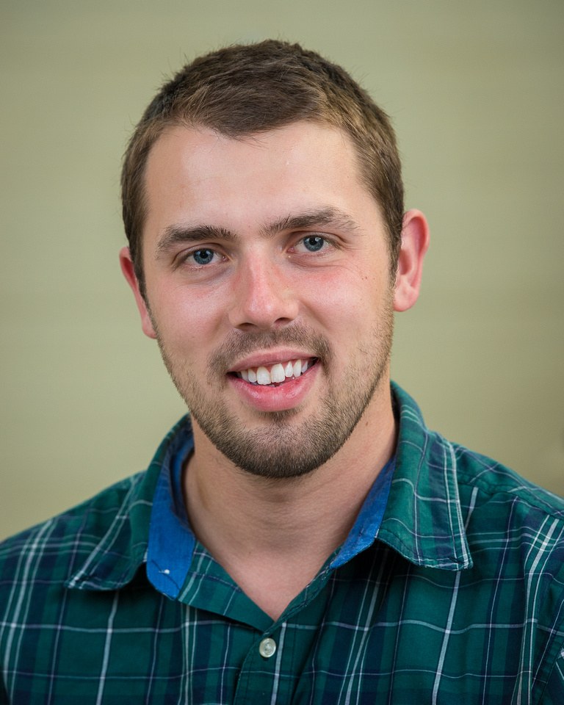
Professional synopsis:
I am a dynamic and creative individual who is enthusiastic about science and marine technology. I am a very positive and organized person and am well-known for my passion as well as my ability to adapt to varying work environments. I have strong leadership skills which I have demonstrated throughout my scuba diving career, and work well independently as well as part of a team. I am very adept at time-management and have demonstrated this both in the workplace and in an education setting.
Objective:
- To work in a marine environment that utilizes my skills in ocean technology, mechanical engineering, and scuba diving.
Education:
- Nova Scotia Community College
  - Ocean Technology
  - Mechanical Engineering Technology
- Dalhousie University
  - Bachelors of Science, Major in Psychology
Previous work experience/ Project experience:
- H.U.E.T. Rescue Diver for Survival Systems Inc.
- PADI certified Dive Instructor and Sales Associate for Torpedo Rays Dive Shop
- Previous work experience as a Research Assistant in Dr. Leslie Phillmore’s laboratory in the Department of Psychology and Neuroscience, Dalhousie University
- Volunteer work on sustainable farms while travelling in New Zealand
- General Manager, Giant Tiger

Other pertinent information:
- Board Member for St. George’s Tennis Club
- Student council member representing the Oceans technology class at NSCC waterfront campus
- Volunteer for Nova Scotia Designer Craft’s Council
- Certified PADI Open Water Dive Instructor
- Emergency First Responder instructor
- St. John’s Ambulance Certified in CPR, Standard and Emergency First Aid
- Certified in Marine Emergency Duties A3
- Certified in Fall Arrest

NSCC Oceans Technology 2014-2015
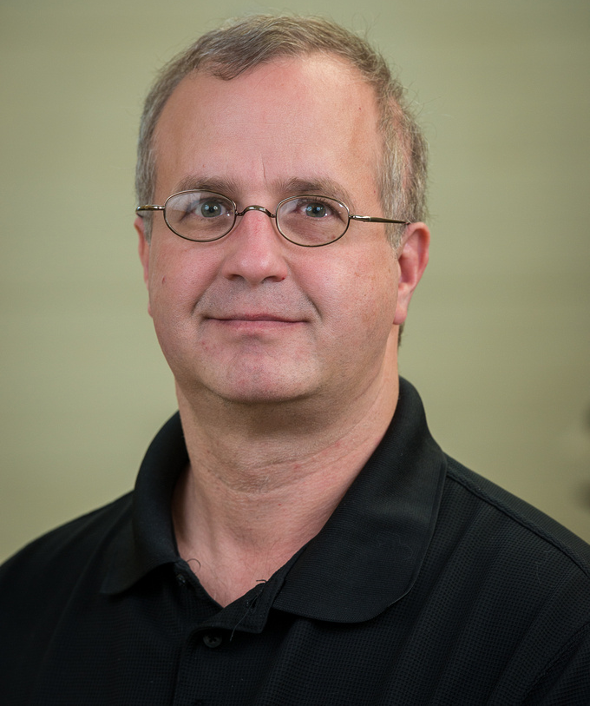
Name: Sean Dzafovic
Professional Synopsis:
I have a varied educational and employment background encompassing geology, computer programming and electronics. I am looking for a field of employment that will combine my various educational backgrounds. I would be most interested in employment in a research capacity, developing and testing prototype oceanographic equipment or work with ROVs/AUVs. I have a strong work ethic and I would be willing to work in any capacity required either in an onshore or offshore role.
Education:
Electronic Engineering Technology diploma, NSCC 2009
Computer Systems Technology diploma, Northern Alberta Institute of Technology, Edmonton, AB 2001
BSc. (Geology) Dalhousie University 1994
Background:
In addition to the education noted above, I have also worked on electronics on my own time. My particular interest is controlling Arduino-based electronics with Android mobile applications.
My computer Systems Technology diploma was mostly database development (SQL and VBA) with some C++. Since graduation I have been learning Javascript and “No SQL” databases such as MongoDB.
A life-long interest of mine has been astronomy. Five years ago, I began teaching a course for new observers in association with the Halifax Centre of the Royal Astronomical Society of Canada.
Previous work experience / project experience:
I worked for the NSCC Applied Energy Research Lab, where I helped to develop a prototype vibration sensor. I built some of the associated hardware as well as doing some LabView programming.
I designed and built a light pollution mapping device as a requirement for graduation from the Electronic Engineering Technology program at NSCC. The device integrated input from a GPS and Sky Quality Meter (SQM) light sensor. As part of this project, I wrote a C# application to convert the stored luminance and location data to KML, so the information could be displayed on Google Maps/Google Earth.
I was a member of the NSCC ROV team for the international MATE ROV competition during my first year at NSCC in 2009-2010. I was responsible for some of the project documentation and the design of a high pass filter for the hydrophone system of the ROV.
I have also written mobile applications for Android and iOS platforms using the Corona SDK. An example of the software written was a volumetric calculator for hydrocarbon-bearing formations.
I was a database analyst for DataWorks Canada, where I maintained a database of 1 million + contact records for Canadian businesses, which were sold to clients for direct mail marketing purposes.
Jack Tsao
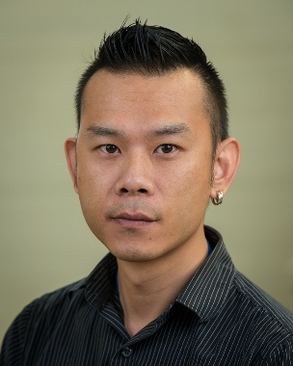
Professional synopsis:
I am an industrious and devoted professional with extremely strong mechanical aptitudes melded with a varied applied sciences academic background. I have highly developed problem-solving skills that aid in timely project completion targets. I have been commended for my ability to work in a team-oriented environment, most recently demonstrated in my position as a research assistant at the post-secondary institution from where I had graduated and have returned to further my studies in Ocean Technologies. I am a dedicated practitioner to sustainable environmental practices and seek to create an impact in this area which I believe I can achieve through my current studies.
Objective:
- To find a job supporting scientists and researchers in the ocean technology sector as a mechanical designer / ocean technologist
Education:
- Seneca Collage of Applied Arts and Technology
  - Computer Programming and Analysis
- Nova Scotia Community College
  - Mechanical Engineering Technology (Honours)
  - Ocean Technology
Background:
- 15 year career in I.T. as a software engineer specializing in: usability / user interface design / HCI (app and web development)
- Left I.T. career in search of new challenges
  - Wanted to work in physical sciences / engineering
  - Trying to tie together acquired skills: programming / mechanical / oceans / electronics
- Fish keeping entire life: currently practice aquaculture (fish / freshwater shrimp breeding for retail), build and invent devices for aquaculture
Previous work experience / project experience:
- NSCC Applied Research – Mechanical Technologist, Research Associate
  - Ocean & Engineered Technologies, Renewables
    - Invented / developed new form of dynamic non-destructive testing
      - (exploring I.P. patent)
    - Worked on experiment focussing on Oil spill detection using SONAR in deep ocean
- BIO – Student (work term)
  - Invented / developed sediment coring hand tool
  - Designed pressure case for underwater camera flash
  - Maintained CTD, deep ocean coring tool, water sampling tools (Niskin bottles, CTD, glider etc.)
- NSCC Applied Research – Research Assistant
  - Renewables
    - Designed Solar PV array rack mount
- NSCC I.T. Services – Student Technical Assistant
- Aqua Nation LTD. – Customer Service / Customer Technical Support
- Canada Wide Medical Assessments - Consultant
Other pertinent information:
- Mechanical Lead NSCC ROV Team 2013
- Mechanical Design Consultant NSCC ROV Team 2014
  - Top placed Canadian team in M.A.T.E. International Competition
  - Designed / assisted in development of camera gimbal
    - Assisted and improved arm / claw design
- Mechanical Design Consultant NSCC ROV Team 2015
Jacob Marshall

Professional synopsis:
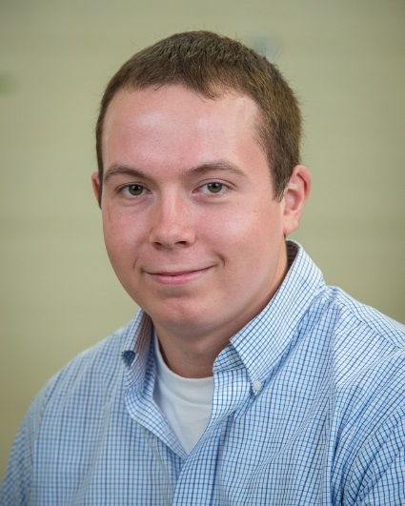
I am very adept in project management; from inception through to completed product as has been evidenced in previous work in Mechanical Engineering Technology. I am a productive and devoted professional with extremely strong mechanical aptitudes melded with a varied applied sciences academic background; I pay very close attention to detail. Further, through my work as a Reserve Forces soldier, I have developed strong leadership capabilities as well as furthered my capacity to work within a group dynamic. My problem-solving skills are very strong and I approach my work in a logical and organized fashion. My goal, after completion of the Oceans Technology program, is to employ and dedicate my varied skill-set in an environment that is engaged in sustainable environmental practices. I believe my aforementioned strengths and ‘hands-on’ abilities shall make me a successful within this expanding and critically important field.
Objective:
- To find a job in the ocean technology sector as a mechanical designer / ocean technologist.
Education:
- Nova Scotia Community College
  - Ocean Technology Program
  - Mechanical Engineering Technology Program Graduate
Previous work experience:
- Canadian Forces Reserve Combat Engineer – Second in Command
  - Manage a team of eight
  - Schedule shifts
  - Plan and organize material for jobs
- Guardian Transfer and Storage – Truck Forman
  - Customer service
  - Manage a team of Five
  - Inventories, documentation and billing.
- FMF Cape Scott (Work term)
  - Maintenance
  - Trouble shouting
  - Repair
Other pertinent information:
- Safety Management Course
- Shielded Metal Arc Welding I
- Beginner metal arc welder with experience
- Beginner Oxy-fuel cutter with experience
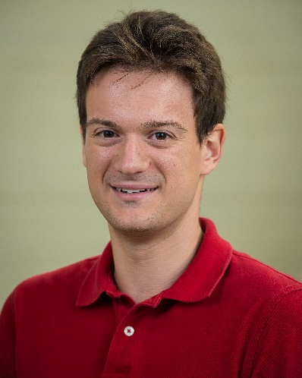
Justin Barkhouse
Professional Synopsis:
I am an extremely motivated individual with a strong biology background with a focus in ecology, statistics and aquaculture. I am a highly skilled problem solver, who works well in a team environment to complete projects efficiently. I can also work effectively on my own and have recently demonstrated this as a research assistant at Mount Allison University. I am deeply interested in aquaculture and fisheries and believe my current studies will enable me to make a positive impact in this industry.
Objective:
- To find a job supporting researchers and industry in the aquaculture and fisheries sector as an oceans technologist
Education:
- Mount Allison University Class of 2012
- Bachelor of Science; Major in Biology
Background:
During my undergraduate degree I took several courses in aquaculture where I learned the basics of water chemistry and the theory of how to successfully raise fish in a variety of settings. I also have practical skills from working in an ichthyology lab and maintaining fish aquariums for several years. My statistics background has taught me how to input data, to analyze the data and to interpret the results. I want to pursue a career in aquaculture, and believe the Oceans Technology Advanced Diploma will give me the practical knowledge and skills to achieve this goal.
Previous work experience / project experience:
- Mount Allison Teaching Assistant
- Prepared labs for 3rd and 4th year biology students
- Supervise and address questions during labs
- Mount Allison Research and Lab Assistant
- Designed and built a recirculating aquarium system for juvenile sturgeon
- Catching, tagging and tracking Atlantic Sturgeon in the St. John River
- Collect and record American Robin Song
    - Analyze and input data into a sound analyzing software
- Pets Unlimited Sales Associate
- Maintained over 50 aquariums
    - Fish health
    - Aquarium maintenance and repair
- Promote and sell aquarium products
Skills/Qualifications:
- Microsoft Word, Excel, PowerPoint and Access
- Statistical and analytical programs: Image J, ANOVA and co-variance testing, RAVEN, R, InStat
- Workplace Hazardous Materials Information Systems (WHMIS)
- Occupational Health and Safety (OH & S)
- Standard First Aid AED CPR “C”
- Fall Protection
- Marine Medical Duties A3
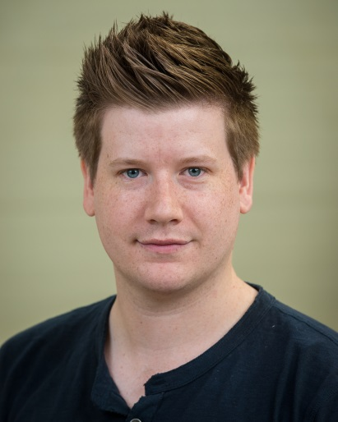
Nova Scotia Community College
Oceans Technology Advanced Diploma

Tyler Boucher BSc Marine Biology
I am an enthusiastic and friendly Dalhousie alumnus. I finished my final year of my Bachelor of Science degree with a Major in Marine Biology in October of 2010. I am currently enrolled in the inaugural class of the Oceans Technology program at Nova Scotia Community College’s Waterfront Campus. I knew I wanted to pursue an ocean-related career from an early age and was drawn to the Oceans Technology program by the applied education it would provide.
I have completed university-level courses such as Marine Ecology, Ecology and Evolution of Fishes, Marine Mammals, Marine Physiology, and Methods in Animal Behaviour. I have also completed my PADI open water scuba diving course. These courses have provided me with experience working in both laboratory and field environments, working with others and scientific writing. Though I am looking forward to all of the Ocean Technology courses, I am most interested in Marine Acoustics, Sampling Systems and Methods, Underwater Photography and the Remote and Autonomous Vehicles. I hope to utilize my background in biology while gaining technical skills through this new and innovative program.
Objective
- Gain applied technical knowledge to assist in employment in the ocean technology sector
Education
- Dalhousie University
  - Bachelor of Science in Marine Biology
Certification
- Standard First Aid Training Level C CPR/AED
- Occupational Health and Safety
- Workplace Hazardous Materials Information System
- Marine Emergency Duties A3
- PADI open water scuba diving

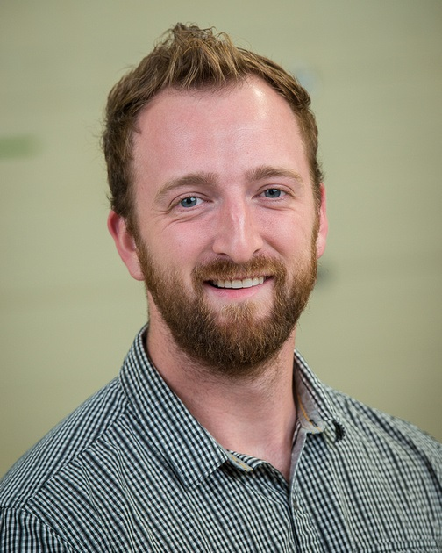
Cris Thomas Seaton
Professional synopsis:
I am a passionate and highly motivated engineering professional with a diverse experience in both the academic and private industry. I have developed proficient analytical and communication skills and have been highly recognized for my work ethic and innovative problem solving. My accomplishments in engineering have generated a strong desire to work in the oceans technology industry to design efficient and economical solutions to the wide range of current oceans challenges. Aided with my experience in the Oceans Technology program at NSCC, I hope to have the skills and knowledge to implement these solutions. I also see a great value in assessing the impacts from anthropogenic processes within the ocean to ensure the sustainability of applications both environmentally and financially.
Objective:
- To acquire a position with a leading ocean technology engineering company, working on technology and process related solutions.
Education:
- Nova Scotia Community College
  - Oceans Technology Advanced Diploma
- Dalhousie University
  - Bachelor of Engineering
  - Bachelor of Science
Previous work experience:
- NSCC School of Trades and Technology – Program Assistant, Oceans Technology
  - Handled major and minor procurement for the program, focusing on comparative report building and shop set up
- Dalhousie University – Mechanical Engineering Assistant (co-operative work term)
  - Designed and manufactured scale model horizontal axis tidal turbine
  - Configured and calibrated propeller dynamometer for measuring torque and thrust for power calculations
  - Devised towing tank testing procedure
- Martec Limited – Engineering Student (co-operative work term)
  - Focused on computational fluid dynamic modeling in the blast and explosion division
Relevant project experience:
- Soluna Energy and Dalhousie University
  - Intertidal zone turbine proof of concept and prototype development of vertical axis tidal turbine
- Schottel GmbH, SVA Potsdam and Dalhousie University Industry Liaison & Innovation
  - Assisted and observed towing tank experiments of horizontal axis scale model tidal turbine
  - Accepted publication in 9th International Conference on Marine Technology (MARTEC 2014)
- Engineering Senior Design Project: monitoring and assessing energy efficiency of rooftop greenhouse
  - Monitored Life Science Centre and developed advanced model to predict annual energy loss
  - Assessed the cost and CO₂-equivalent savings from alternative glazing material and heating sources
- Publication in Journal of Fluid Dynamics for Efficient Semi-Analytical Methodology for the Pre-Design Analysis of the Shock Response of Marine Structures
  - ASME 2013 32nd International Conference on Ocean, Offshore and Arctic Engineering
Relevant safety and training milestones:
- Marine Emergency Duties A3 certification
- St. John Ambulance First Aid and CPR/AED certification
- WHMIS and OHS certification
- Fall Arrest certification
- Small Boat Operator licence
- Advanced Open Water Diver (SSI certification)
NSCC OTAD Class of 2014-2015

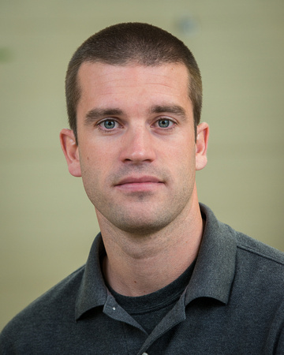
Name:

D. Grant MacLeod

Education:

- NSCC – Oceans Technology
- B.Ed. (Phys Ed./Health and Biology) - University of Maine
- B.Sc. (Kinesiology) - University of New Brunswick

Objective:

- My objective is to find employment as an Oceans Technologist.

Background:

Throughout my childhood and adolescence I was very active in scouts and athletics, which led me to pursue degrees in both Kinesiology and Education. Since graduating, I have been a teacher for five years at both elementary and secondary levels. I have taught a variety of subjects including physical education, law, biology, ESL, and career development to students with a wide range of abilities. Three of these years were spent overseas teaching in South Korea. This experience furthered my passion for travel and interest in learning about different cultures. Having worked in a foreign language environment, I improved my communication and interpersonal abilities. Over my five years of teaching I have been commended on my excellent organizational and problem solving skills. I am also a devoted professional with a strong ability to effectively lead a team. These skills that I have developed through teaching will be transferable to work in the Oceans Technology field. My interest in the ocean developed from a young age spending summers on the beach and fishing with my family. Throughout my travels, I have seen the natural beauty but also the environmental damage that’s occuring throughout the world, so I am strongly committed to safe environmental practices to preserve our oceans. My traits of passion, enthusiasm, dedication, and sincerity have driven my success so far. I believe these traits, my experiences, and my interest in the ocean, will allow me to have a successful career in Oceans Technology.

Previous work experience:

- SIS Canada (British Columbia Offshore School)
  - Elementary/Secondary Physical Education, Law 12 Teacher
- Cobequid Educational Centre
  - Secondary Life Skills Physical Education/Career Development Teacher
- Maple Ridge Elementary School
  - Elementary Physical Education Teacher
- Ganggu Middle School
  - Secondary English as a Second Language Teacher

Other pertinent information:

Outside of the classroom I have volunteered to coach a variety of athletic clubs including soccer, basketball, and running club. When I am not working or in school I enjoy being outdoors, hiking, backpacking, traveling, and spending time with my family. I have a Nova Scotia Teaching Certificate and a British Columbia Teaching certificate. I am also a Chief Scout, a certified PADI Open Water Diver, and a Level B licensed coach. My training milestones include: First Aid/CPR, MED A3, Fall Arrest, OHS/WHIMIS, Small Boat Operations, and a Criminal Record Check.

